1. Using MR GREEN list the 7 characteristics of living things.  
   M  
   R  
   G  
   R  
   E  
   E  
   N
2. Classify the following as living, non-living or dead  
   a.) Orange juice:  
   b.) Mushroom:  
   c.) Chair:  
   d.) Paper:  
   e.) Sunflower oil:
3. What are the names of the 2 lenses in a microscope?
4. What is the function of the stage in a microscope?

**B**

1. 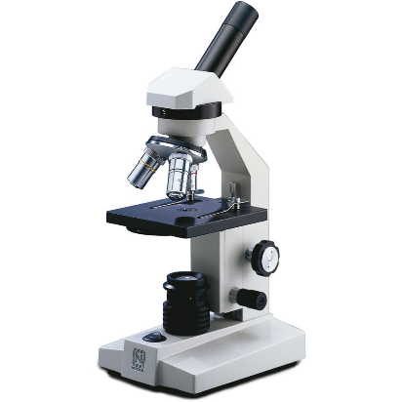Write the names of the labels on the microscope.  
   a.)  
   b.)  
   c.)  
   d.)  
   e.)  
   f.)

**F**

**E**

**D**

**C**

**A**

1. Put a number in front of each step to show the correct   
   order to use a microscope.  
     
   ___Lower the stage and put the slide on it.  
   ___Use the fine focus knob to sharpen the image  
   ___ Place the microscope on a flat surface.  
   ___ Looking from the side, raise the stage to the top  
   ___ Make sure the smallest objective lens is in place.  
   ___ Carry the microscope with two hands.  
   ___Look through the eyepiece lens and turn the coarse focus knob until you see an image
2. List 4 organelles found in both plant and animal cells.  
   1.  
   2.  
   3.  
   4.
3. Write the name of each organelle next to its function.  
   ________ produces proteins  
   ________ Gets rid of waste  
   ________ Allows transport through the cell  
   ________ releases energy from food
4. Write the name and function of one organelle found in plant cells but not animal cells.  
   Name:  
   Function:
5. Label this animal cell  
    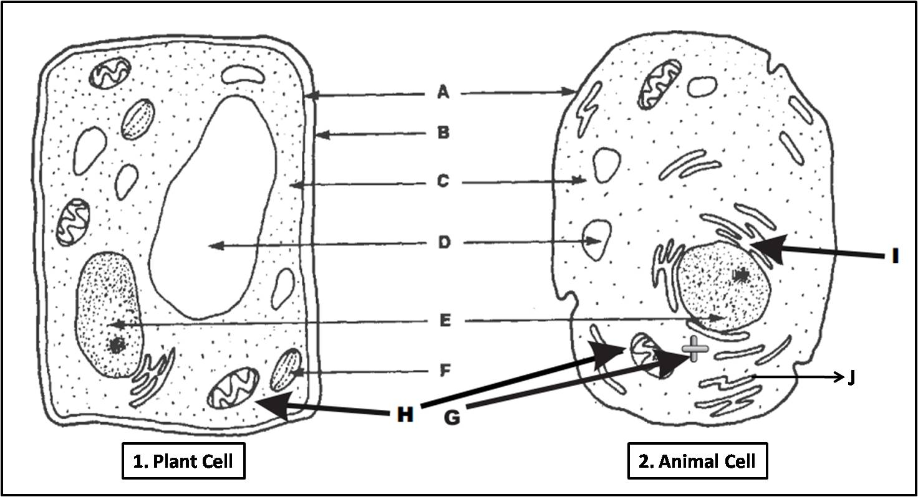
6. Label this plant cell  
    
7. Can fungi make their own food? Why/why not?
8. Circle which types of cells contain a cell wall.  
     
   animal plant fungi
9. Complete the Venn diagram with information about Prokaryotic and Eukaryotic cells

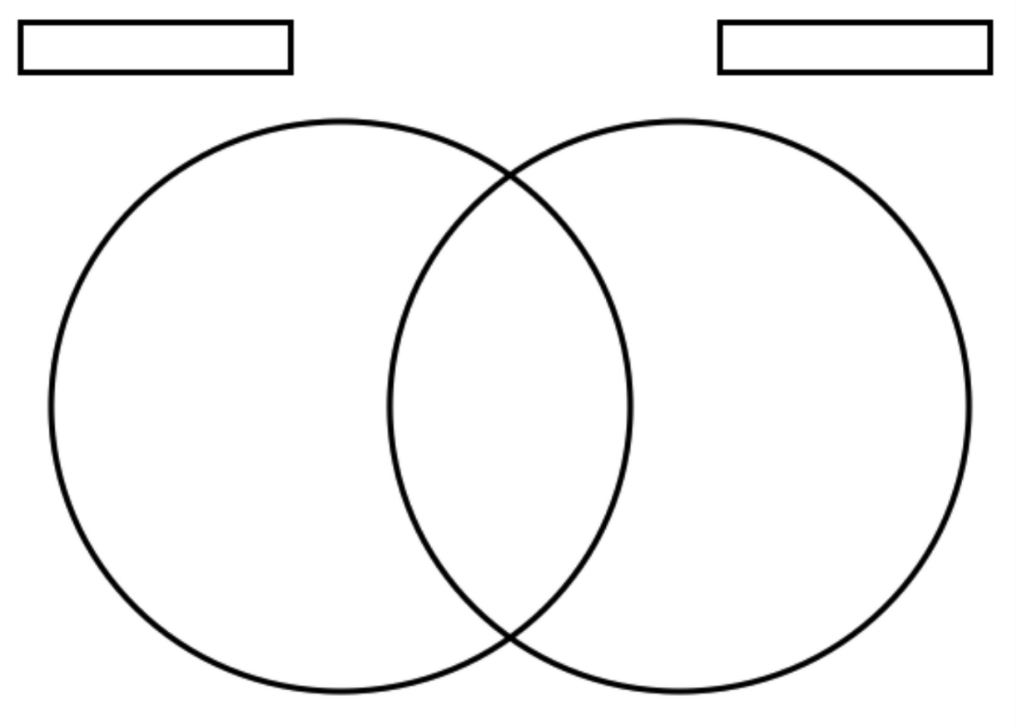

1. Name 2 multicellular and 2 unicellular organisms.  
   Multi: 1. 2.   
   Uni: 1. 2.
2. Name a structure that would help a unicellular organism complete the following:  
   Move:  
   Detect light:  
   Engulf food:
3. Complete the table below about specialised human cells

|  |  |  |  |
| --- | --- | --- | --- |
| Name | Diagram | Adaptation | Function |
| Red blood cell |  | Biconcave shape No nucleus |  |
| Fat cell |  |  | Insulating layer Stores energy |
| Nerve cell |  | Insulated, long |  |
| Muscle cell |  |  | Moves the bones of the skeleton, moves vital organs |
| Reproductive cell |  | Contains half the DNA of a normal cell.  Flagellum |  |